**DAILY ONLINE ACTIVITIES SUMMARY**

|  |  |  |  |  |  |  |  |
| --- | --- | --- | --- | --- | --- | --- | --- |
| **Date:** | **06/06/2020** | | | | **Name:** | **Churashma** | |
| **Sem & Sec** | **4th SEM 'A' Section** | | | | **USN:** | **4AL18CS019** | |
| **Online Test Summary** | | | | | | | |
| **Subject** | | **Data communication** | | | | | |
| **Max. Marks** | | **30** | | **Score** | | **28** | |
| **Certification Course Summary** | | | | | | | |
| **Course** | **Introduction to Cyber security** | | | | | | |
| **Certificate Provider** | | | **greatlearning academy** | **Duration** | | | **3.5 hours** |
| **Coding Challenges** | | | | | | | |
| **Problem statement 1: Write a program in C to rotate an array by N positions.**  **Problem statement 2: Given an array A of size N containing 0s, 1s, and 2s; you need to sort the array in ascending order.**  **Problem statement 3: Write a Java Program to find the second-highest number in an array.** | | | | | | | |
| **Status: completed** | | | | | | | |
| **Uploaded the report in Github** | | | | **yes** | | | |
| **If yes Repository name** | | | | **https://github.com/Churashma/Lockdown-coding** | | | |
| **Uploaded the report in slack** | | | | **yes** | | | |

ONLINE TEST DETAILS: DC test was scheduled from 09:15 am to 10:00am .The portion for the IA was module 5 there were 30 questions and the time assigned was 45 minutes the questions were mcq type.

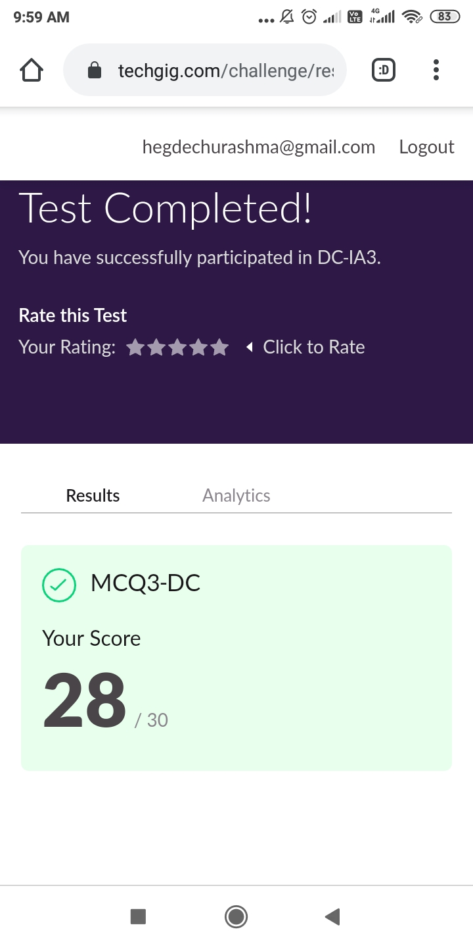

CERTIFICATION COURSE DETAILS: Today I studied about threats and vulnerabilities and also i studied about what is cyber security. Vulnerabilities are the gaps or weaknesses in a system that make threats possible and tempt threat actors to exploit them. Cyber security is the practice of defending computers, servers, mobile devices, electronic systems, networks, and data from malicious attacks. It's also known as information technology security or electronic information security.

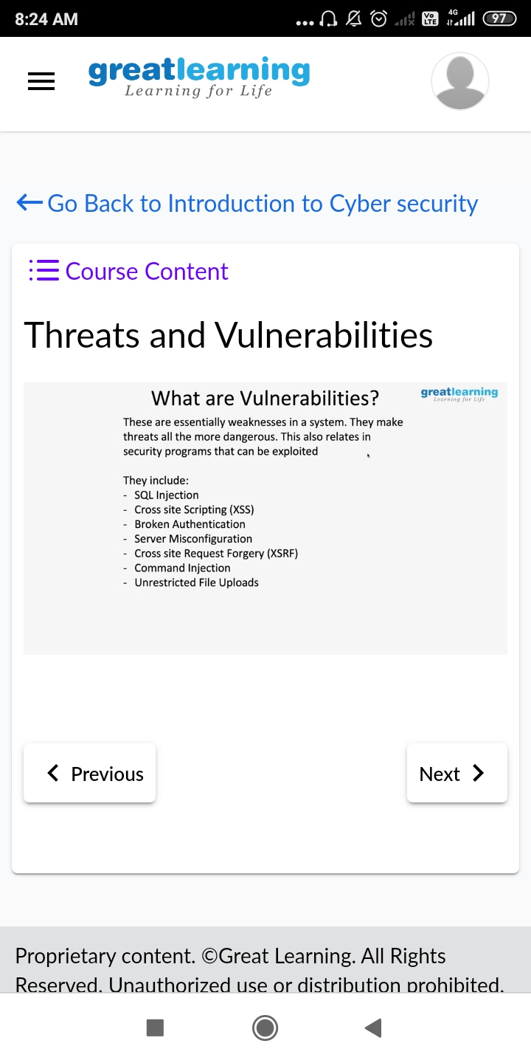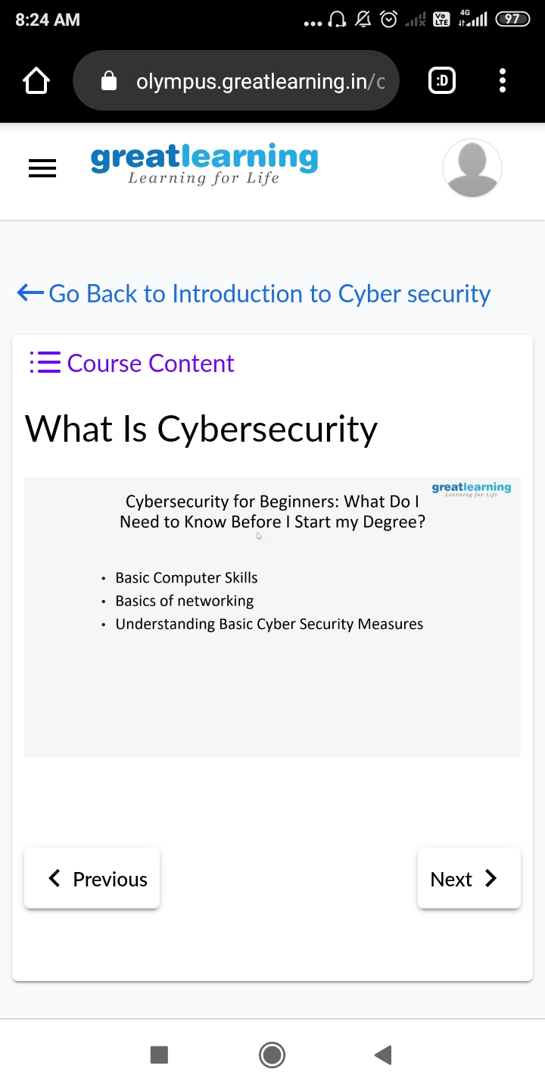

**CODING CHALLENGES DETAILS**:

**Problem statement 1: Write a program in C to rotate an array by N positions.**

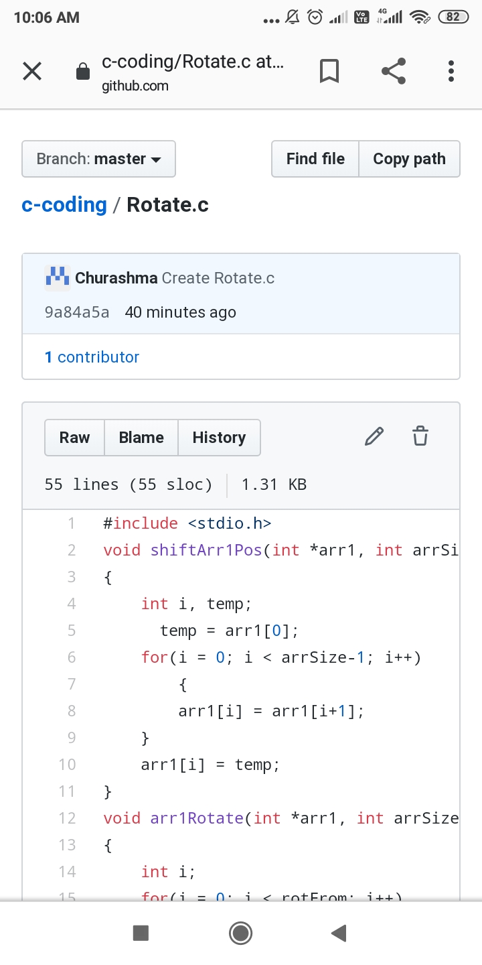

Problem statement 2: Given an array A of size N containing 0s, 1s, and 2s; you need to sort the array in ascending order.

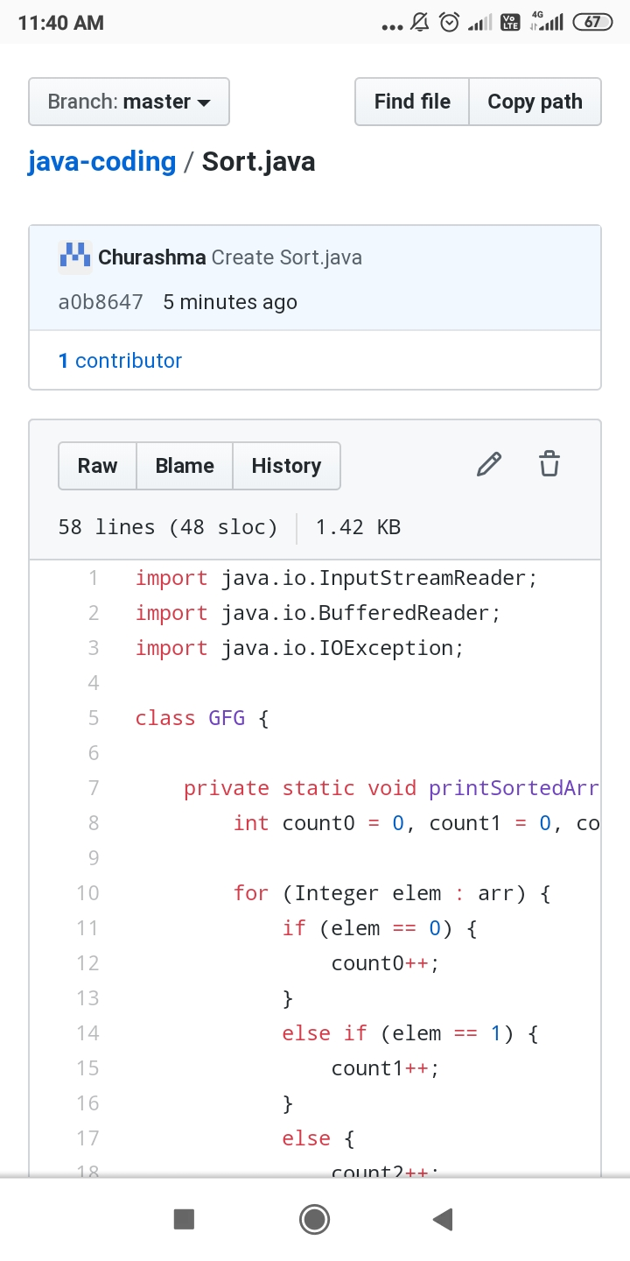

Problem statement 3: Write a Java Program to find the second-highest number in an array.

